REPUBLIC OF THE PHILIPPINES )

CITY OF CEBU ) S.S

# SPECIAL POWER OF ATTORNEY

KNOW ALL MEN BY THESE PRESENTS:

I, Ross Geller, of legal age, Filipino, and with residence at 123 Narra St., Talamban, Cebu City, hereby name, constitute, and appoint Chandler Bing, likewise of legal age, Filipino, and residing at 456 Bayabas St., Banilad, Cebu City, to be my true and lawful Attorney-in-Fact, with full power and authority to do and perform the following specific acts on my behalf, to wit:

* To negotiate and sell my real property located at 789 Fonder St., Maria Luisa Village, Banilad, Cebu City, covered by Transfer Certificate of Title No. 8836HGS, including the power to sign the Deed of Sale and any related documents.
* To represent me before any government agency, financial institution, or private entity in relation to the acts described above, and to sign, execute, and receive any necessary documents.
* To make or receive any payments required in connection with the authorized acts, and to issue corresponding receipts or acknowledgments as needed.
* To do any additional act that may be essential for finalizing the transactions, as if personally done by me.

HEREBY GIVING AND GRANTING my Attorney-in-Fact full authority, as well as ratifying and confirming all that they may lawfully do or cause to be done in the exercise of the powers herein granted.

IN WITNESS WHEREOF, I have hereunto set my hand this 5th day of April, 2025, in the City of Cebu, Philippines.

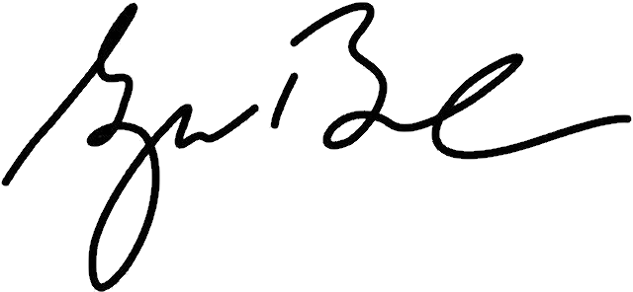

ROSS GELLER

Name of Principal

UMID No.: 8837 77263 12

WITH MY CONFORME:

CHANDLER BING

Attorney-in-Fact

Driver’s License ID No.: G-098 77283

Signed in the presence of: 

JOEY TRIBBIANI RACHEL GREEN

Witness Witness

REPUBLIC OF THE PHILIPPINES )

CITY OF CEBU ) S.S.

BEFORE ME, a Notary Public for and in _________________________, on this ____ day of __________, 20___, personally appeared the persons whose signatures and details are stated above, who acknowledged that the foregoing document is their free and voluntary act and deed.

WITNESS MY HAND AND SEAL on the date and at the place above written.

Doc. No. ______________;

Page No. ______________;

Book No. ______________;

Series of 20___.